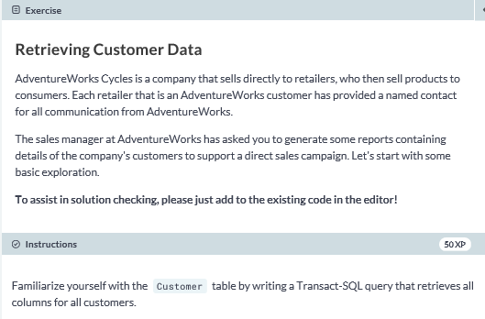

**Select * from SalesLT.Customer;**

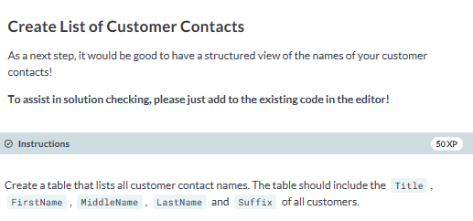

**SELECT Title, FirstName, MiddleName, LastName, Suffix**

**FROM SalesLT.Customer;**

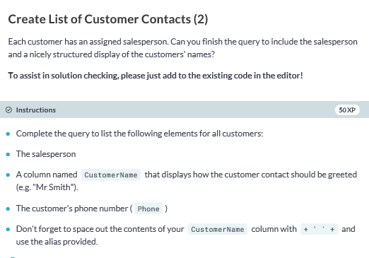

**SELECT SalesPerson, Title + ' ' + LastName AS CustomerName, Phone**

**FROM SalesLT.Customer;**

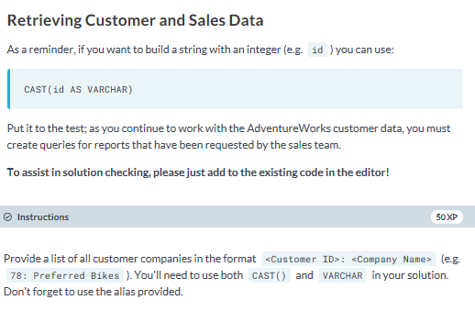

**SELECT cast(CustomerID AS varchar) + ': ' + CompanyName AS CustomerCompany**

**FROM SalesLT.Customer;**

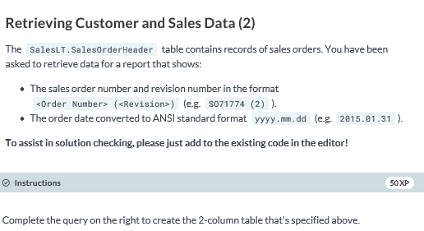

**SELECT CONCAT('SO',SalesOrderID) + ' (' + STR(RevisionNumber,1) + ')' AS OrderRevision,**

**CONVERT(NVARCHAR(30), OrderDate, 102) AS OrderDate**

**FROM SalesLT.SalesOrderHeader;**

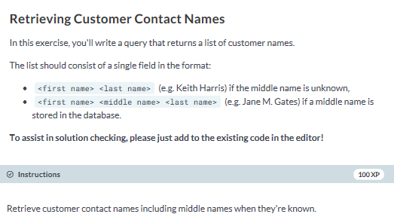

**SELECT FirstName + ' ' + ISNULL(MiddleName+' ', '') + LastName**

**AS CustomerName**

**FROM SalesLT.Customer;**

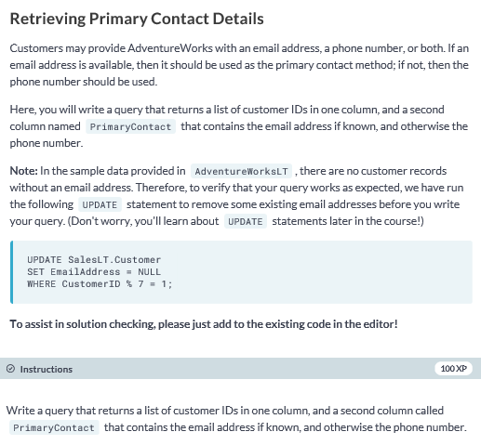

**SELECT CustomerID, COALESCE(EmailAddress, Phone) AS PrimaryContact**

**FROM SalesLT.Customer;**

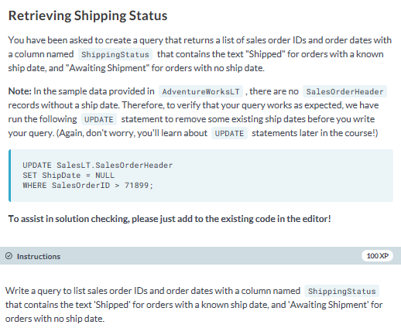

**SELECT SalesOrderID, OrderDate,**

**CASE**

**WHEN ShipDate IS NULL THEN 'Awaiting Shipment'**

**ELSE 'Shipped'**

**END AS ShippingStatus**

**FROM SalesLT.SalesOrderHeader;**